**DAILY ONLINE ACTIVITIES SUMMARY**

|  |  |  |  |  |  |
| --- | --- | --- | --- | --- | --- |
| **Date:** | **8-06-2020** | | **Name:** | **Shah Dhruvil Amit** | |
| **Sem & Sec** | **6th - B** | | **USN:** | **4AL17CS083** | |
| **Online Test Summary** | | | | | |
| **Subject** | **CNSC** | | | | |
| **Max. Marks** | **60** | **Score** | | **38** | |
| **Certification Course Summary** | | | | | |
| **Course** | **Python programming** | | | | |
| **Certificate Provider** | **E-box** | **Duration** | | | **2 hours** |
| **Coding Challenges** | | | | | |
|  | | | | | |
| **Status: executed** | | | | | |
| **Uploaded the report in GitHub** | | **Yes** | | | |
| **If yes Repository name** | | <https://github.com/DhruvilShah99/Daily-Updates> | | | |
| **Uploaded the report in slack** | | **Yes** | | | |

CNSC IA - 3

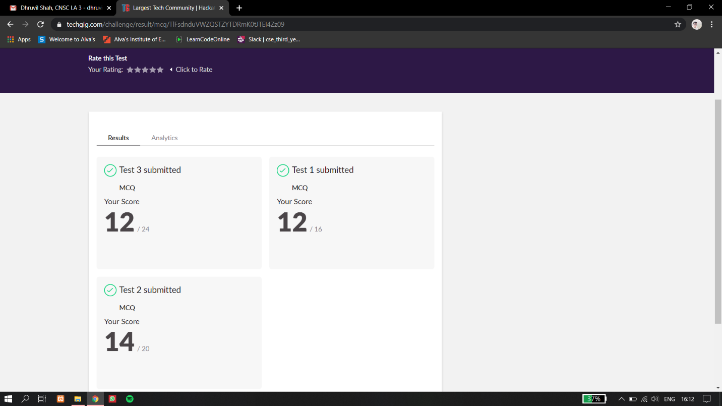

Certification Course Details:

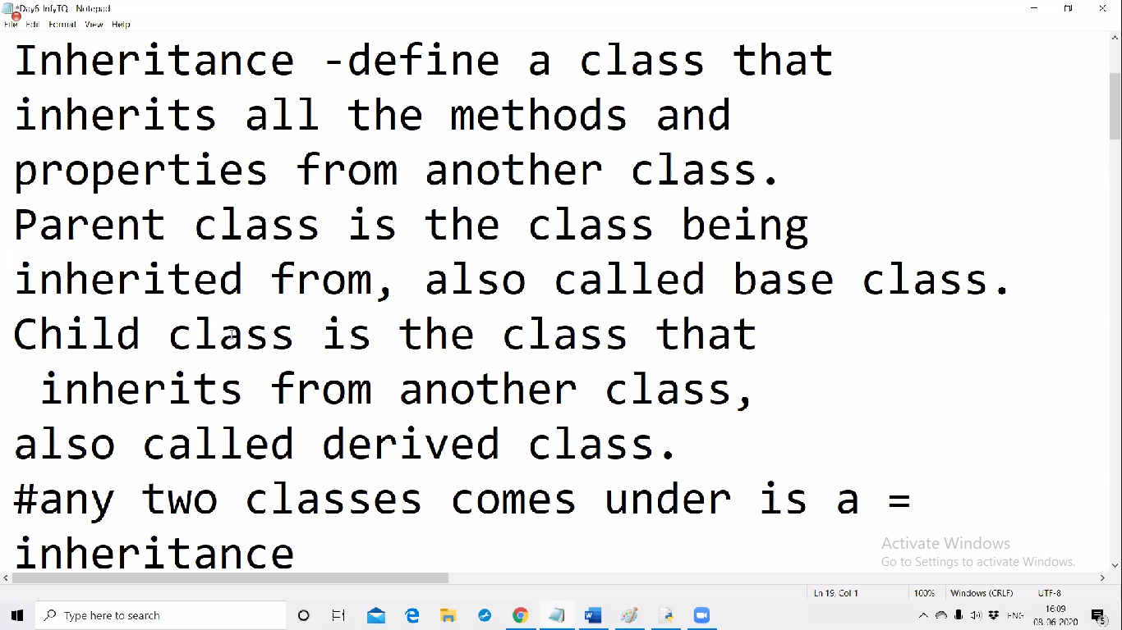

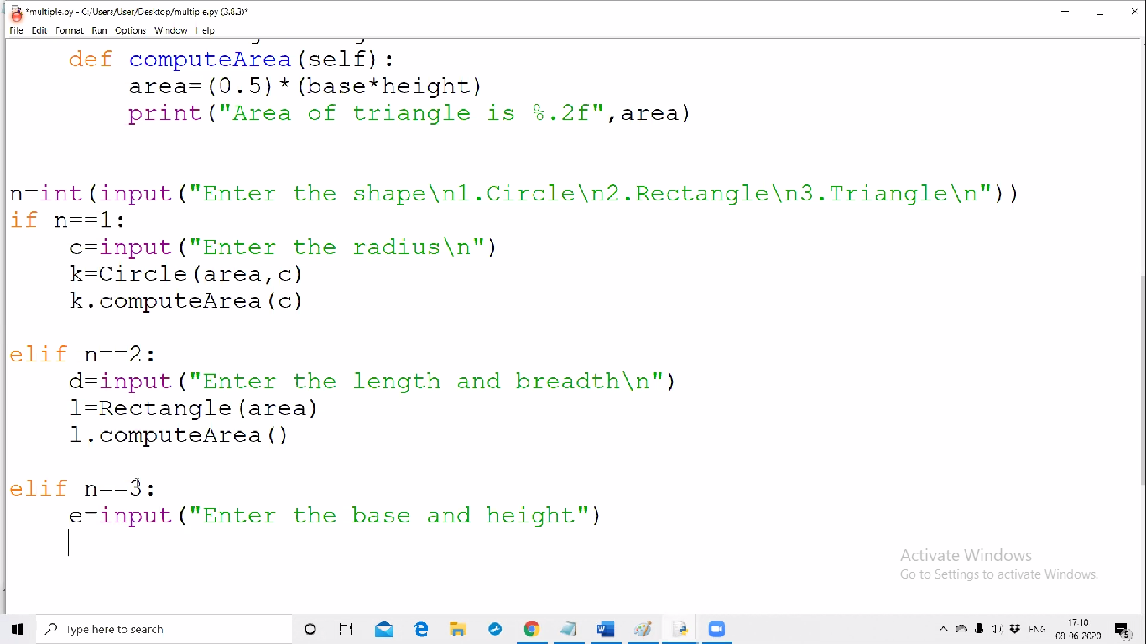

Today I have learnt about inheritance which includes inheriting the methods and the properties from another class and also how parent and child class relation works.

Coding Challenges Details:

The below GitHub link for details

<https://github.com/DhruvilShah99/Daily-Updates>

P-1

Python program to check whether given string Is palindrome or not.

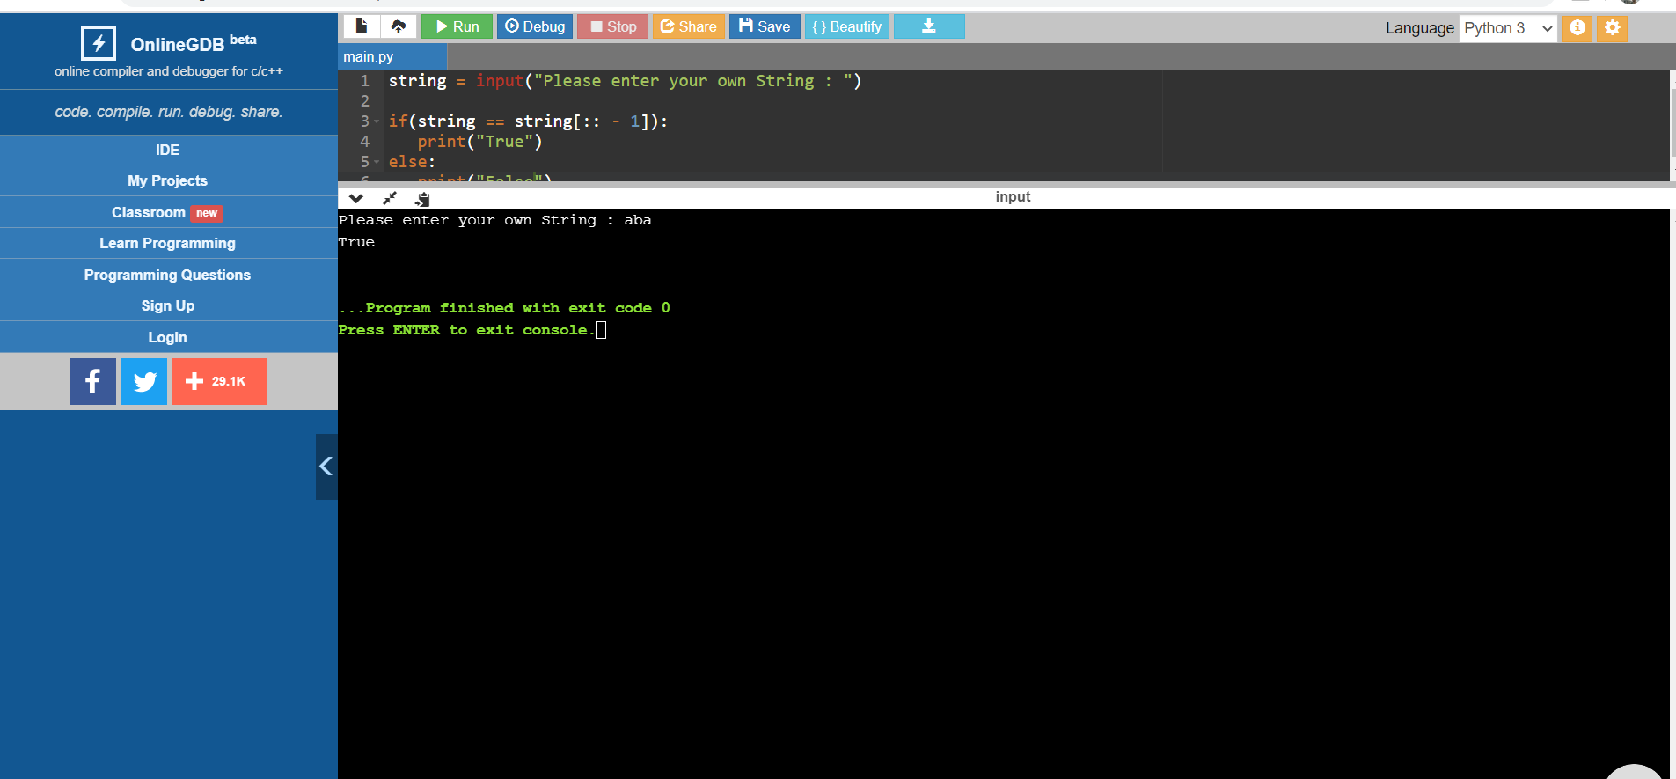

**P-2**

**C++ program to Check whether a number can be represented as difference of two squares**

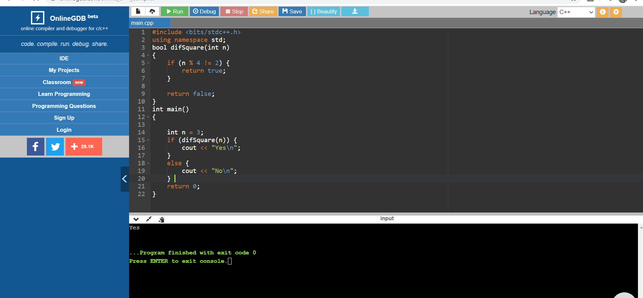

P-3

Java program to implement delete node from middle of singly linked list

